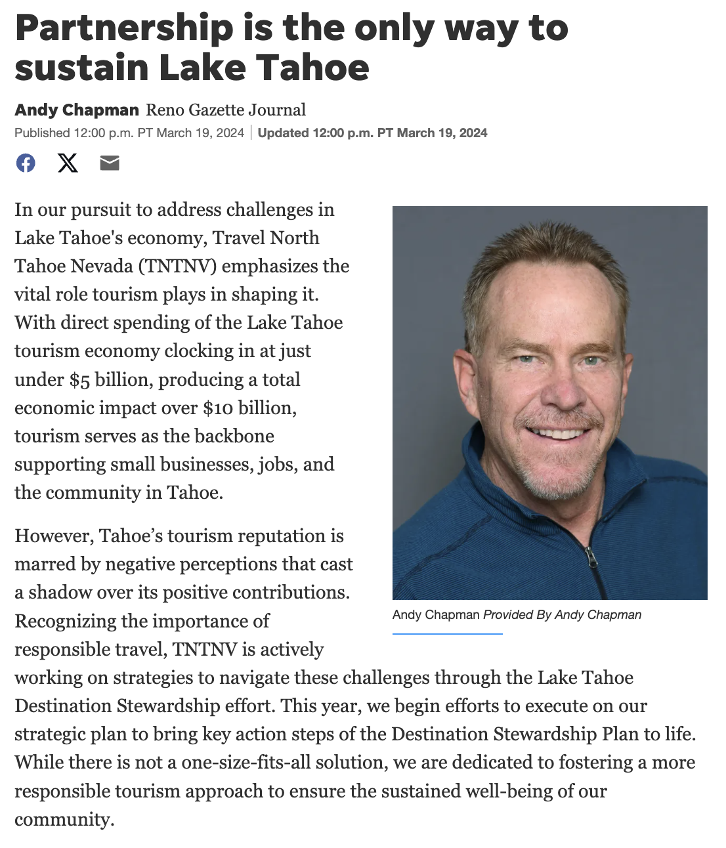

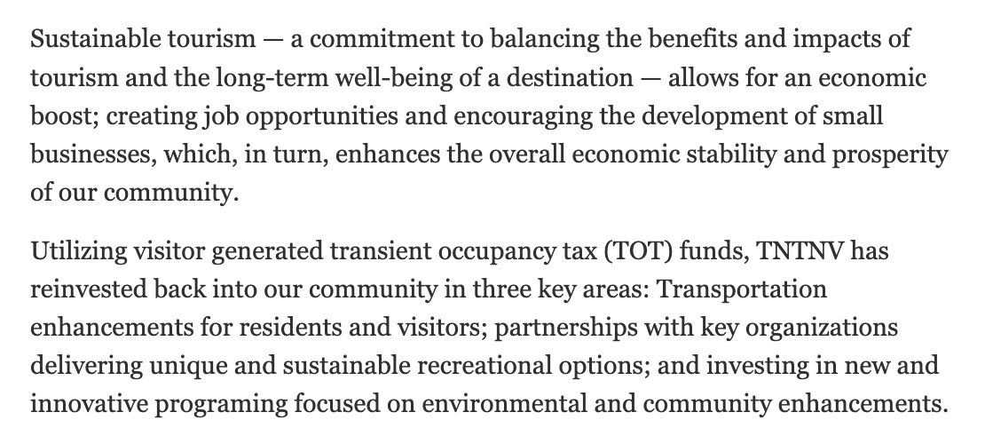
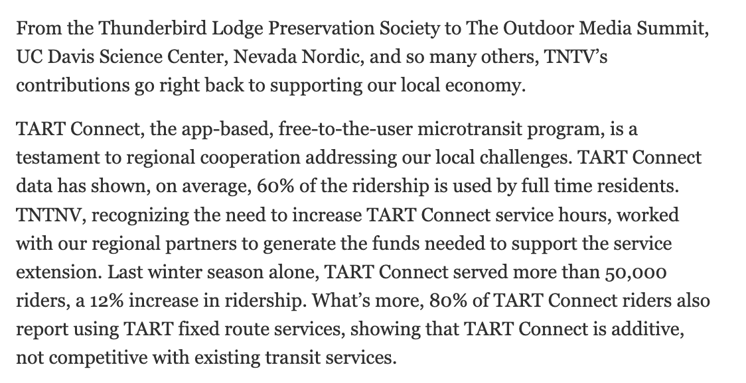
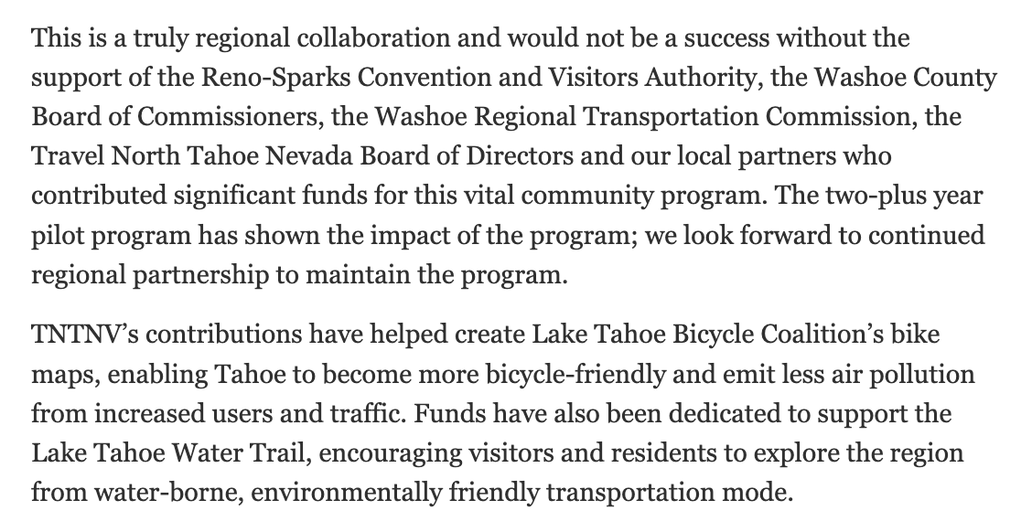
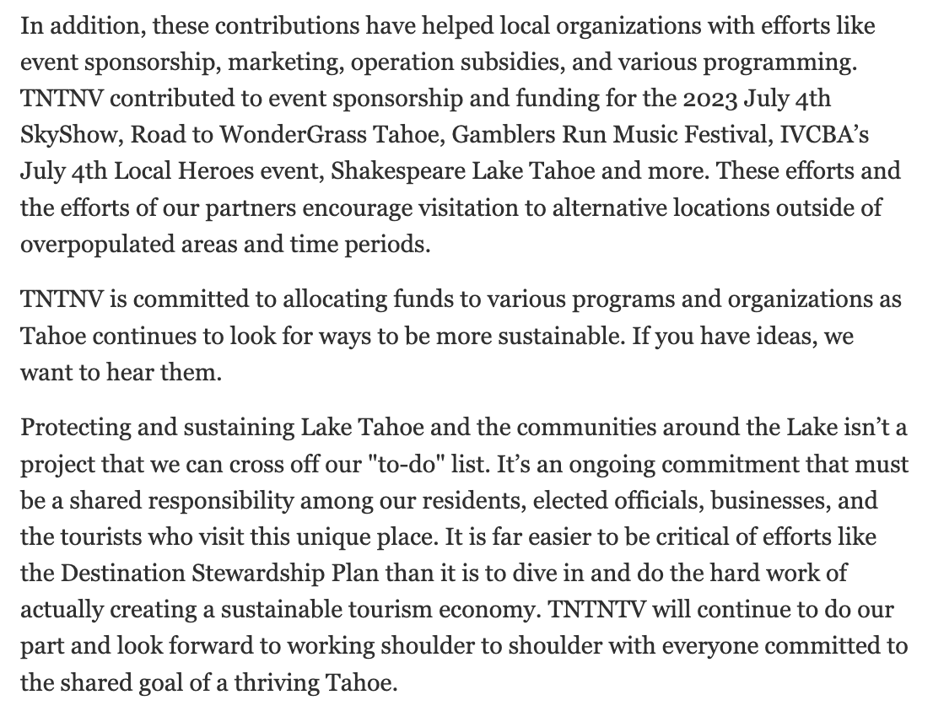

Andy Chapman is president and CEO of Travel North Tahoe Nevada.

https://www.rgj.com/story/opinion/2024/03/19/partnership-is-the-only-way-to-sustain-lake-tahoe/73030312007/

